**GITHUB FLOW-CHART**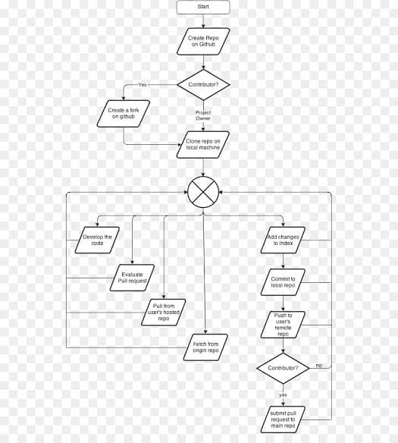

**Certainly! GitHub Flow is a lightweight, branch-based workflow for collaborating on code using GitHub or other Git-based version control systems. Here are the key steps in GitHub Flow:**

**1. *Create a Branch:* Start by creating a new branch for your work. Typically, you'll create a branch from the main branch (often called "master" or "main"). This branch is where you'll make your changes.**

**2. *Add Commits:* Make your code changes within the branch and commit them regularly. Each commit should represent a logical and incremental change.**

**3.*Creating a Repo*: A Git repository is a virtual storage of your project. It allows you to save versions**

**Of your code, which you can access when needed.**

**4. *Open a Pull Request (PR):* When your code is ready for review or integration, open a Pull Request. This is a request to merge your branch into the main branch. It serves as a discussion and review point.**

**5. *Code Review:* Collaborators or team members review your code within the Pull Request. They can comment, suggest changes, and discuss the proposed changes with you.**

**6. *Merge:* After the code has been reviewed and CI checks pass, the Pull Request is ready to be merged into the main branch. This integrates your changes with the rest of the codebase.**

**7. *Cleanup:* Once the changes have been merged and deployed (if applicable), you can delete the branch that was used for the feature or bug fix.**

**8. *Repeat:* Developers repeat this process for each new feature, bug fix, or improvement, creating branches and Pull Requests as needed.**

**GitHub Flow encourages frequent collaboration and continuous integration, making it a popular choice for teams working on software development projects. It ensures that code changes are well-documented, reviewed, and tested before being merged into the main codebase.**